Hot dip galvanized steel wire mesh grassland Kraal mesh

Product Description
1. Brief Description:
In agriculture, fences are used to keep animals in or out of an area. They can be made of a variety of materials, depending on the terrain, location and the animal to be restrained. The average height of most agricultural fences is about 4 feet (1.2 meters), and in some places the height and structure of pens used for livestock are regulated by law.

Protect your investment with woven fences, the most reliable fences for cattle, pigs and other large animals. The braided field fence features the monarch knot, which acts as a hinge that is provided under pressure and then allows the fence to spring back into shape.

2. Standard specification:
Sizes | No. of Warp Wire | Roll Width | Warp & Weft Wire Diameter
 |  |  | Edge Warp Wire | Middle Weft Wire | Warp Wire
8/110/15 | 8 | 1100mm | 2.5mm | 2.5mm or 2mm | 2.5mmor 2mm
5/70/30 | 5 | 700mm | 2.5mm | 2.5mmor 2mm | 2.5mmor 2mm
6/90/30 | 6 | 900mm | 2.5mm | 2.5mmor 2mm | 2.5mmor 2mm
7/90/30 | 7 | 900mm | 2.5mm | 2.5mmor 2mm | 2.5mmor 2mm
8/110/30 | 8 | 1100mm | 2.5mm | 2.5mmor 2mm | 2.5mmor 2mm
5/70/60 | 5 | 700mm | 2.5mm | 2.5mmor 2mm | 2.5mmor 2mm
6/100/60 | 6 | 1000mm | 2.5mm | 2.5mmor 2mm | 2.5mmor 2mm
7/90/60 | 7 | 900mm | 2.5mm | 2.5mmor 2mm | 2.5mmor 2mm
7/110/60 | 7 | 1100mm | 2.5mm | 2.5mmor 2mm | 2.5mmor 2mm
8/110/60 | 8 | 1100mm | 2.5mm | 2.5mmor 2mm | 2.5mmor 2mm

- Type
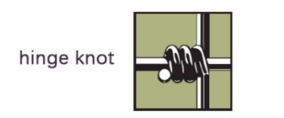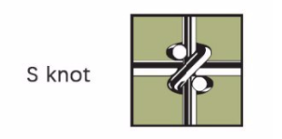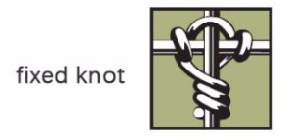

- Manufacturing process
Horse wire mesh fence is made by high strength steel wire woven together, then finished with hot dipped galvanized.

5. Application
Pasture fence, also known as cattle fence, sheep fence and grassland fence, has novel and firm structure, flat surface, uniform opening and good integration.
It is used for the boundary line of fields and grasslands to raise deer, cattle and other animals.

6. Packaging and transportation of fences
1. Each roll shall be wrapped with waterproof plastic film and bound with belt
2. One 40HQ container is loaded with 25-26 tons

